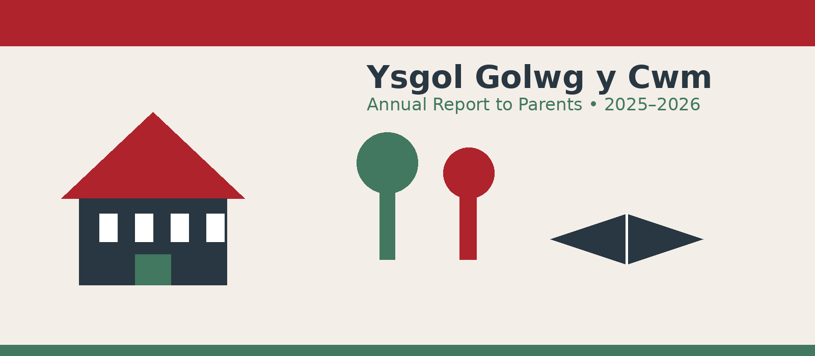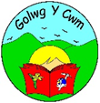
Adroddiad Blynyddol i Rieni
2025 – 2026
Report from the Governing Body to Parents and Carers

Headteacher | Mrs Tracey Havard
Deputy Headteacher | Mrs Allison Griffiths

Message from the Chair of Governors
On behalf of the Governing Body, I am pleased to present this Annual Report to Parents for 2025–2026. The report provides an overview of governance, school improvement, curriculum, attendance, inclusion, community engagement, finance and the many activities that have enriched pupils’ experiences during the year.
Our governors have continued to meet regularly with school leaders, reviewing school performance, curriculum development, staffing, pupil matters, finance and safeguarding. We would like to thank the whole school community—children, staff, families, volunteers and community partners—for their continued commitment to Ysgol Golwg y Cwm.
We are particularly proud of the breadth of opportunities provided to pupils during the year, from sporting festivals, music and arts to residential experiences, Welsh-language activities, community projects and charity work. We look forward to continuing to support the school’s priorities and its commitment to helping every child become a confident, capable and caring member of the community.
Huw Williams
Chair of Governors

2025–2026 at a glance
177  pupils on roll | 92%  overall attendance | 79  pupils on the ALN register
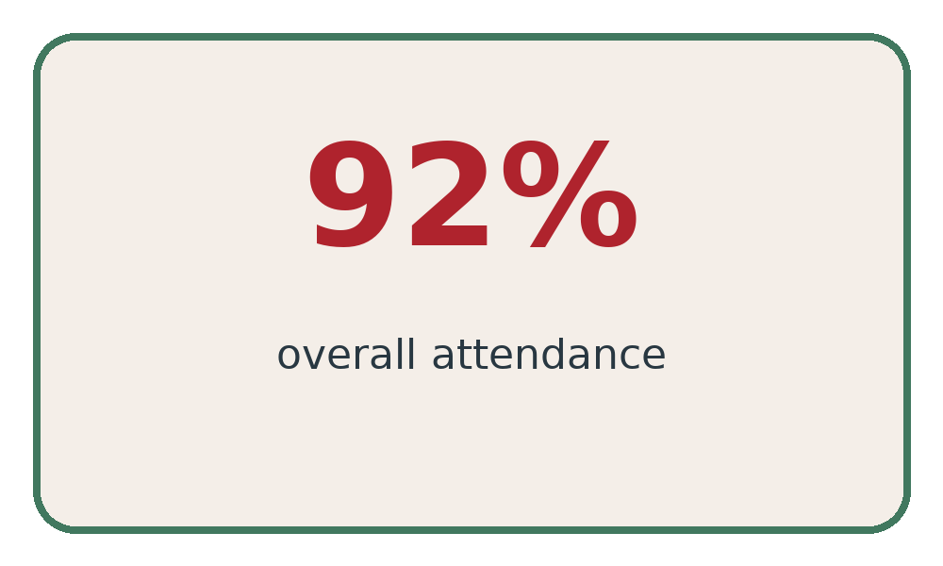
Attendance was recorded at 92% in Autumn 2025, Spring 2026 and Summer 2026, giving an overall figure of 92%.

Who’s Who on the Governing Body
The Governing Body reflects the broad spectrum of the local community. The Chair is elected annually. Governors meet every half-term to discuss school business and set strategic direction, with regular detailed reports from the Headteacher covering staffing, curriculum development and pupil matters. Governors also undertake training organised by Powys County Council.
Governor | Role | Category
Cllr H Williams | Chair | LEA
Mrs N Busby | Vice Chair | Parent
Mr A Williams |  | LEA
Cllr S Williams |  | LEA
Mrs S James |  | Staff
Mrs A Griffiths |  | Staff
Mrs T Havard |  | Headteacher
Mr M Ace |  | Community
Mrs K Gafney |  | Community
Mr Alex DeMelverda |  | Parent
Mrs S Jones |  | Parent
Mrs H Tomas |  | Parent

Clerk to the Governing Body: Mrs B Groves, c/o Powys County Council, Llandrindod Wells, Powys, LD1 5LG.
The Chair of Governors can be contacted via the school at Ysgol Golwg y Cwm, Ystradgynlais, Swansea, SA9 1TS.
The source material records that no travelling allowances were paid to members of the Governing Body.

Staffing and Organisation
Headteacher: Mrs Tracey Havard | Deputy Headteacher: Mrs Allison Griffiths

Teaching staff and classes
Staff member | Class / responsibility
Miss B Seabourne | Dosbarth 6
Ms S Davies | Dosbarth 5/4
Ms D Rowe | Dosbarth 3/4
Mrs N Edwards | Dosbarth 2/3
Mrs C Williams | Dosbarth 1/2
Mrs S Gerard | Reception/1
Mrs H Bennett | STF KS2
Mrs E Miller | STF Foundation Phase
Mrs T Havard | ALNCO
Miss J Williams / Mrs N Watkins | 2-year-old setting / Flying Start
Mrs Adele Elton | 3/4-year-old setting

Support and wider staff
Support staff: Mrs S Bufton, Mrs J Lewis, Mrs L Phillips, Mrs H Bateman, Miss S Leahy, Miss V Leahy, Mrs S James, Mrs S Carter, Miss S Whitney, Miss E Phillips, Miss K Williams, Miss R Lewis, Mrs G Dell, Mrs D Hopkins and Mr C Gwylim, Miss A James, Miss K Evans.
School administrators: Mrs D Ace and Mrs N Ace.
Kitchen: Mrs M Owen (Cook) and Mrs D Davies.
Caretaker: Mr R Colamazza.
Cleaners: Mrs L Holland and Mrs G Davies.
Specialist provision and enrichment staff include Miss S Davies (Welsh), Mrs D Clear (Singing, Strings) and Mr Ray Dizon (Drums).

School Improvement and Curriculum

The School Improvement Plan is reviewed by the Governing Body and senior management team. Area Learning Teams monitor standards and provision within their curriculum responsibilities, while staff development and performance-management objectives are aligned to identified priorities.

Key improvement priorities
- Improve reading across the school.
- Improve Cymraeg skills across the school.
- Improve ALN procedures across the school.
- Improve and develop independent learning skills.

Curriculum organisation
Both Foundation Phase and KS2 classes are organised into mixed-age groups, with mixed-age groups apart from Year 6. Planning builds on pupils’ prior knowledge and interests while ensuring appropriate curriculum coverage. The Literacy and Numeracy Framework (LNF) and Digital Competence Framework (DCF) are planned for weekly. New themes begin with “Dysgu Gyda’n Gilydd” sessions, while older pupils also have opportunities through Genius Hour to follow individual interests.

Curriculum for Wales – A Curriculum for Life
The school’s curriculum aims to develop ambitious, capable learners; enterprising, creative contributors; ethical, informed citizens of Wales and the world; and healthy, confident individuals.

Welsh Language, Inclusion and Additional Learning Needs

Use of Welsh
Ysgol Golwg y Cwm is an English-medium school with Welsh taught as a second language. Welsh is incorporated throughout school life through greetings, questions, phrases and vocabulary, with pupils encouraged to use Welsh in classrooms, the playground, dining hall and assemblies. Pupils develop listening, speaking, reading and writing skills progressively, with Key Stage 2 opportunities including writing for different purposes and Welsh drama.
Cymraeg Campus
The school has achieved the Bronze Cymraeg Campus award and is continuing to work towards the Silver award.

Additional Learning Needs
Mrs T Havard is the ALNCO, responsible for maintaining the ALN Register and organising support. The source report records approximately 79 pupils on the register. The school works with parents, classroom teachers, specialist staff, Powys Educational Psychology and other partner agencies. Individual Development Plans are reviewed regularly and parents are consulted about progress.

Specialist Teaching Facilities
The Specialist Centres are part of Local Authority provision hosted by the mainstream school. They provide intensive educational support for pupils with significant additional learning needs and also provide outreach support to schools in the area.

Equality and accessibility
The school is committed to equal opportunities and inclusion. The report also records three disability-friendly toilets within the school.

Attendance, Health and Safety

Attendance
Term | Overall attendance
Autumn 2025 | 92%
Spring 2026 | 92%
Summer 2026 | 92%
Overall | 92%
Attendance strategies include regular reminders about punctuality and attendance, Educational Welfare Officer follow-up, first-day contact with parents where an absence has not been reported, and letters to parents of poor attenders.
The school notes that there are 365 days in a year, but only 195 are school days, and authorised holiday absence is considered in relation to overall attendance.

Healthy eating
The school is part of the Healthy Schools Network and promotes healthy eating and drinking. Parents are encouraged to provide fruit or healthy snacks and water at break times.

Security, health and safety
- Visitors sign in and out at main reception.
- Exterior gates are locked during the school day and access is through the main entrance.
- Governors and the Headteacher carry out regular health and safety checks, alongside Local Authority inspections.
- Half-termly fire drills and lock down drills take place for staff and pupils.
- Annual testing is undertaken for alarms, extinguishers, emergency lighting, boilers and heating systems.
- The Local Authority undertakes regular legionella testing and portable electrical appliance testing.
- Safeguarding procedures are known to staff, and the school has a lockdown policy.

Finance and Resources – 2025/26
The delegated school budget is allocated by the Local Authority using a number of factors, including pupil numbers, additional learning needs and premises requirements. Governors agree the school budget and monitor it throughout the year with school management and Local Authority finance officers.
Budget measure | 2025/26
Pupil numbers | 177
Total delegated funds | £1,094.662
Salaries & wages | £937,397
Premises | £89,038
Supplies & other expenses | £26,612
Net expenditure | £1272,213
Planned under/(overspend) | (10,528)
Under/overspend CF | £32,955
The figures above are reproduced from the supplied annual-report material.

Parents, PTA and Community

PTA
The school has an active Parent Teacher Association supporting fundraising and social activities. Parents are welcomed at PTA meetings and are encouraged to help plan and organise events.
- Halloween Disco
- Christmas Fete
- Bags for School
- Pumpkin Competition
- Tip Top Friday
- Easy Fundraising
- Christmas raffle
- Pop-up tuck shop
- Doughnut event
- Funding support for beach trips, a Life Vac and Year 6 leavers’ treats
- Selection boxes and Easter eggs for all children

Charity and community giving
- Children in Need – PJ Day
- School Food Bank
- Community Dreams
- Pink for Saria
- Hello Yellow – mental health
- Odd Socks – Anti-Bullying
- Christmas Jumper – UNICEF

Community-focused school
Ysgol Golwg y Cwm is a Community Focused School, with community-based offices and hire facilities. The school uses the local community as a teaching and learning resource and welcomes community groups into school. The report notes that the school has been identified within an Estyn best-practice report for community and parent engagement.

A Year of Learning, Sport, Culture and Community
The supplied report records a wide range of visits, visitors, events and enrichment opportunities. Highlights include:
- Christmas concerts for Foundation Phase and KS2, attended by families.
- Sporting festivals and competitions in football, netball, rugby, cross country and hockey.
- Participation in the Swansea Apollo Football Tournament and Swansea Valley 7s rugby tournament.
- Fit Fortnight activities with local rugby, football and sports organisations.
- Residential trips to Llangrannog and the Summit Centre, plus the whole-school summer trip to Aberavon Beach.
- World Book Day, book fair, library visit and a grant-supported focus on reading across the school.
- St David’s Day Eisteddfod celebrations and participation in the Ystradgynlais St David’s Day parade.
- Music opportunities including ukulele, singing, Pbuzz, drums, woodwind and a whole-school Wales National Orchestra performance.
- Visits and workshops involving Mid Wales Opera, Urdd, Ospreys players, Swansea FC, PC Swift, the fire service and other partners.
- Year 5 and Year 6 transition and enrichment activities with Ysgol Maesydderwen.
- Development of the forest area, installation of a sensory room and installation of Caban Mawr through Community Focused School Grants.
- School Council community involvement and local banner workshop.
- Resilience work with CAMHS and wider work with partner organisations including CHAMS, CAFCASS, Area 43 and Calan DVS.

Extra-curricular clubs
Netball • Football • ICT • Cymraeg • Gardening • Book/Reading Club • Choir
Thanks are extended to the staff and volunteers who give their time to run these clubs.

Transition, School Life and Parent Partnership

Primary / secondary links
Strong links have been established with Ysgol Maesydderwen and Cwmtawe Secondary School. Secondary subject leaders visit Dosbarth 6 to discuss pupil progress, while Year 5 and Year 6 pupils have opportunities to visit secondary settings and become familiar with staff and their new environment. Additional transition arrangements are made for pupils with ALN.

School day
Foundation Phase | Junior Department
8:50–12:15 morning  10:40–11:00 snack/play  12:15–1:15 lunch  1:15–3:15 afternoon  2:15–2:30 play | 8:50–12:15 morning  10:40–11:00 play  12:15–1:15 lunch  1:15–3:15 afternoon
Breakfast Club: 8:00–8:40am; last entrance 8:30am. Teachers are in classrooms from 8:40am.

School charter and mission
Our school rules
Look after our school; treat others as we want to be treated; be happy learners; try our best; tell the truth; care for ourselves and others; use kind words; remember please, thank you and sorry; make each other feel special; and recognise that everyone is important and differences do not matter.
Mission:
- High expectations for lifelong learners
- Aspirations to succeed
- Feeling safe and valued in our diverse family
- Active, enterprising citizens
- Nurturing each other, never giving up.
- G – gofalu | Y – ysgol ni | C – cymuned

Looking Ahead
The Governing Body will continue to work with school leaders, staff, pupils, parents and partners to monitor the School Improvement Plan, support high-quality teaching and learning, strengthen independent learning, writing and data-handling skills, and ensure assessment arrangements support pupils’ progress. The school will also continue developing its Welsh-language provision and community partnerships.

School contact
Ysgol Golwg y Cwm
Hendreladus
Ystradgynlais
Swansea
SA9 1SE
Tel: 01639 846070
Email: office@golwgycwm.powys.sch.uk
www.golwgycwm.powys.sch.uk

Diolch / Thank you
The Governing Body of Ysgol Golwg y Cwm

