Elsie Edwards
I am Elsie, I think it is very important that we meet often. When we meet, we can talk about finding ways of making the school a happy and better place. 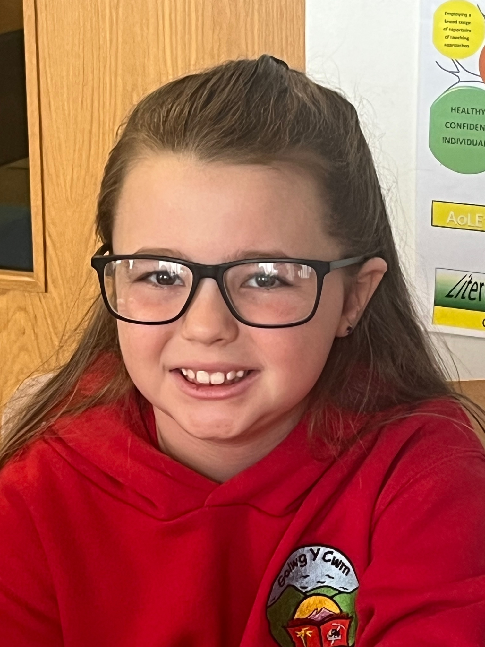

Freya Howells
Being part of the school council is fun. I want to make a difference around the school and to the community.

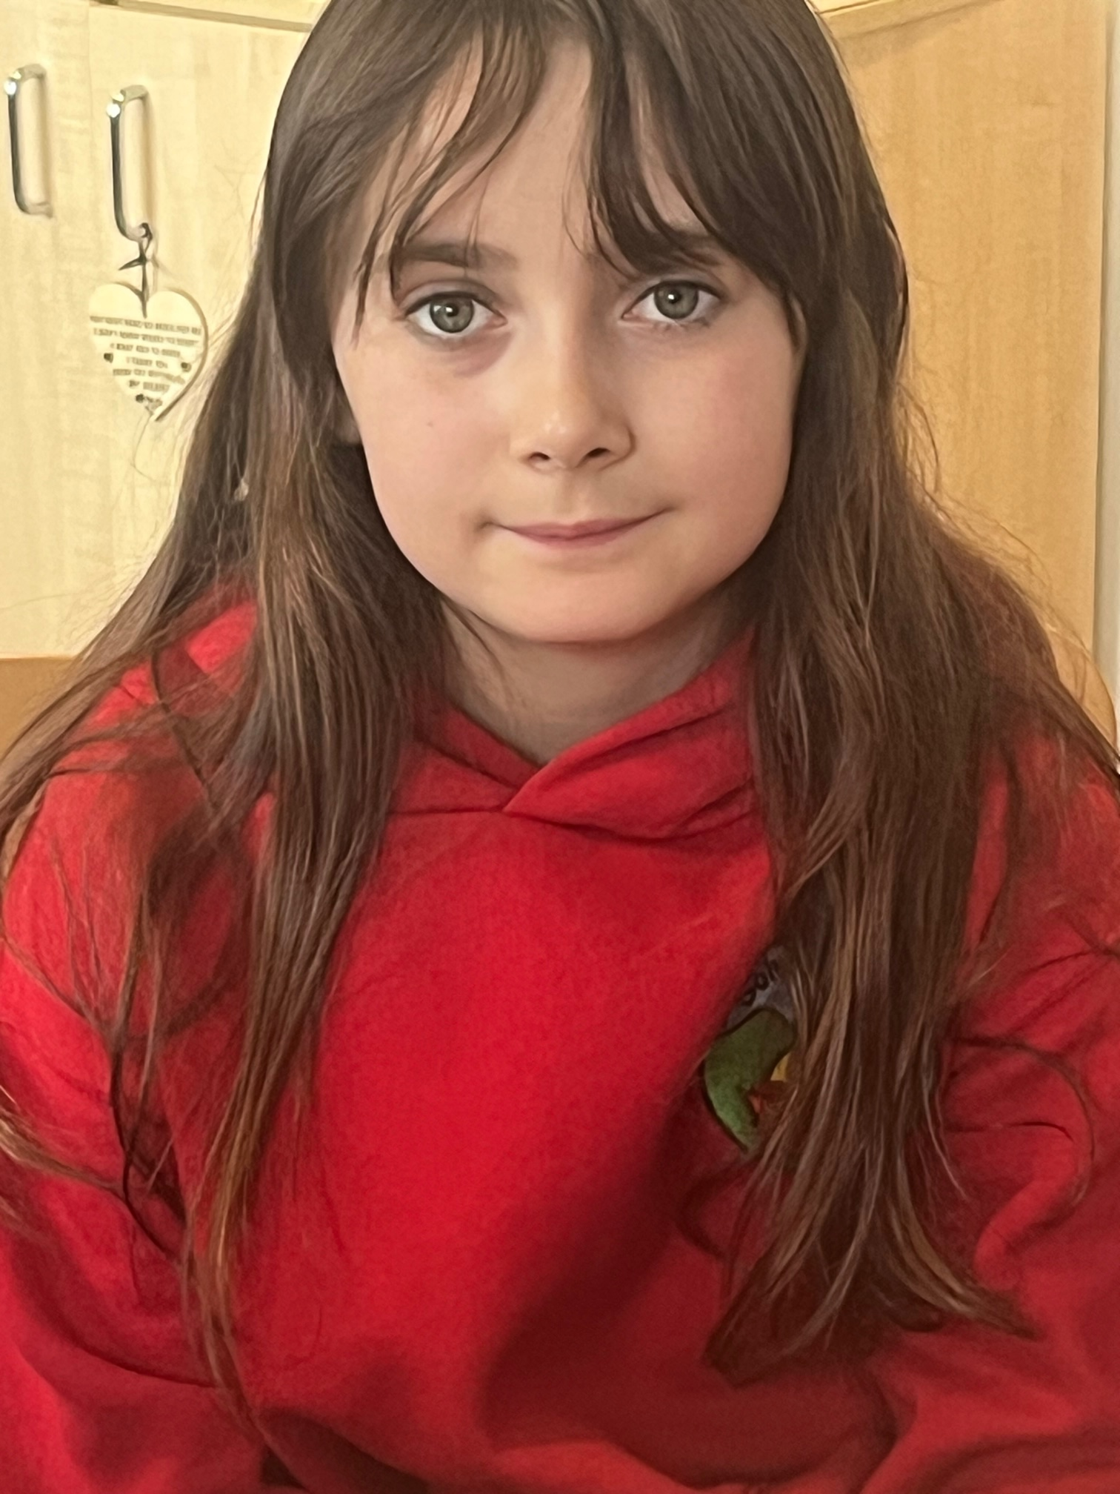

Darcey Lewis
Being on the school council means that I can help out around the yard. I am looking forward to showing visitors around the school when they come to see us.
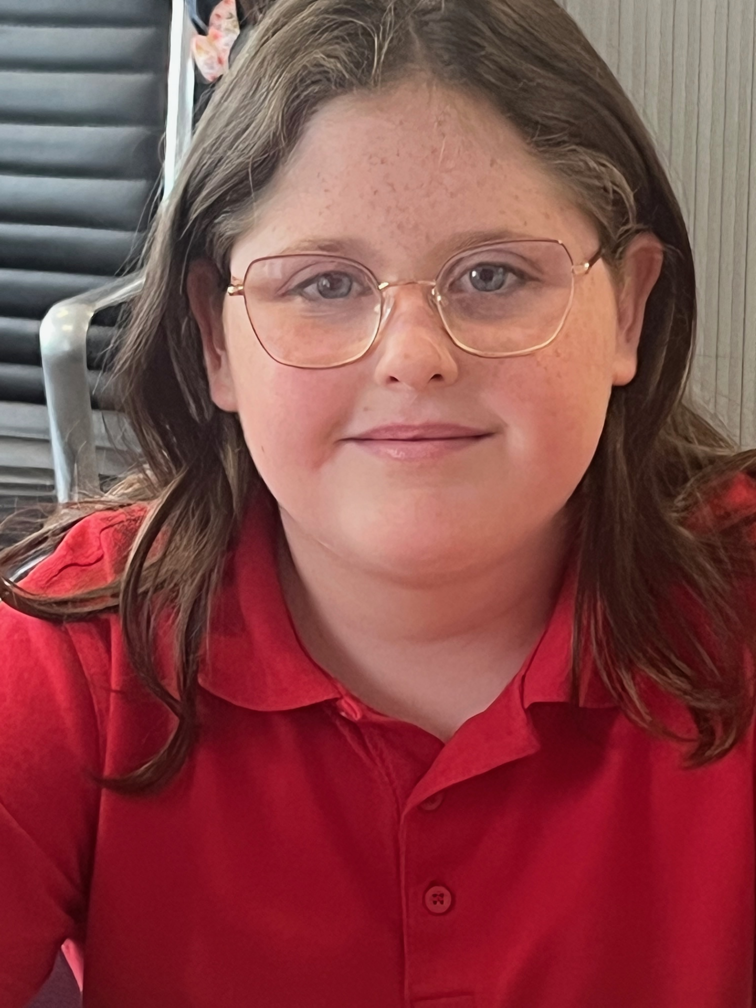

Seren Morgan
I want to become more involved around the school and I want to help out as much as I can and make a difference.
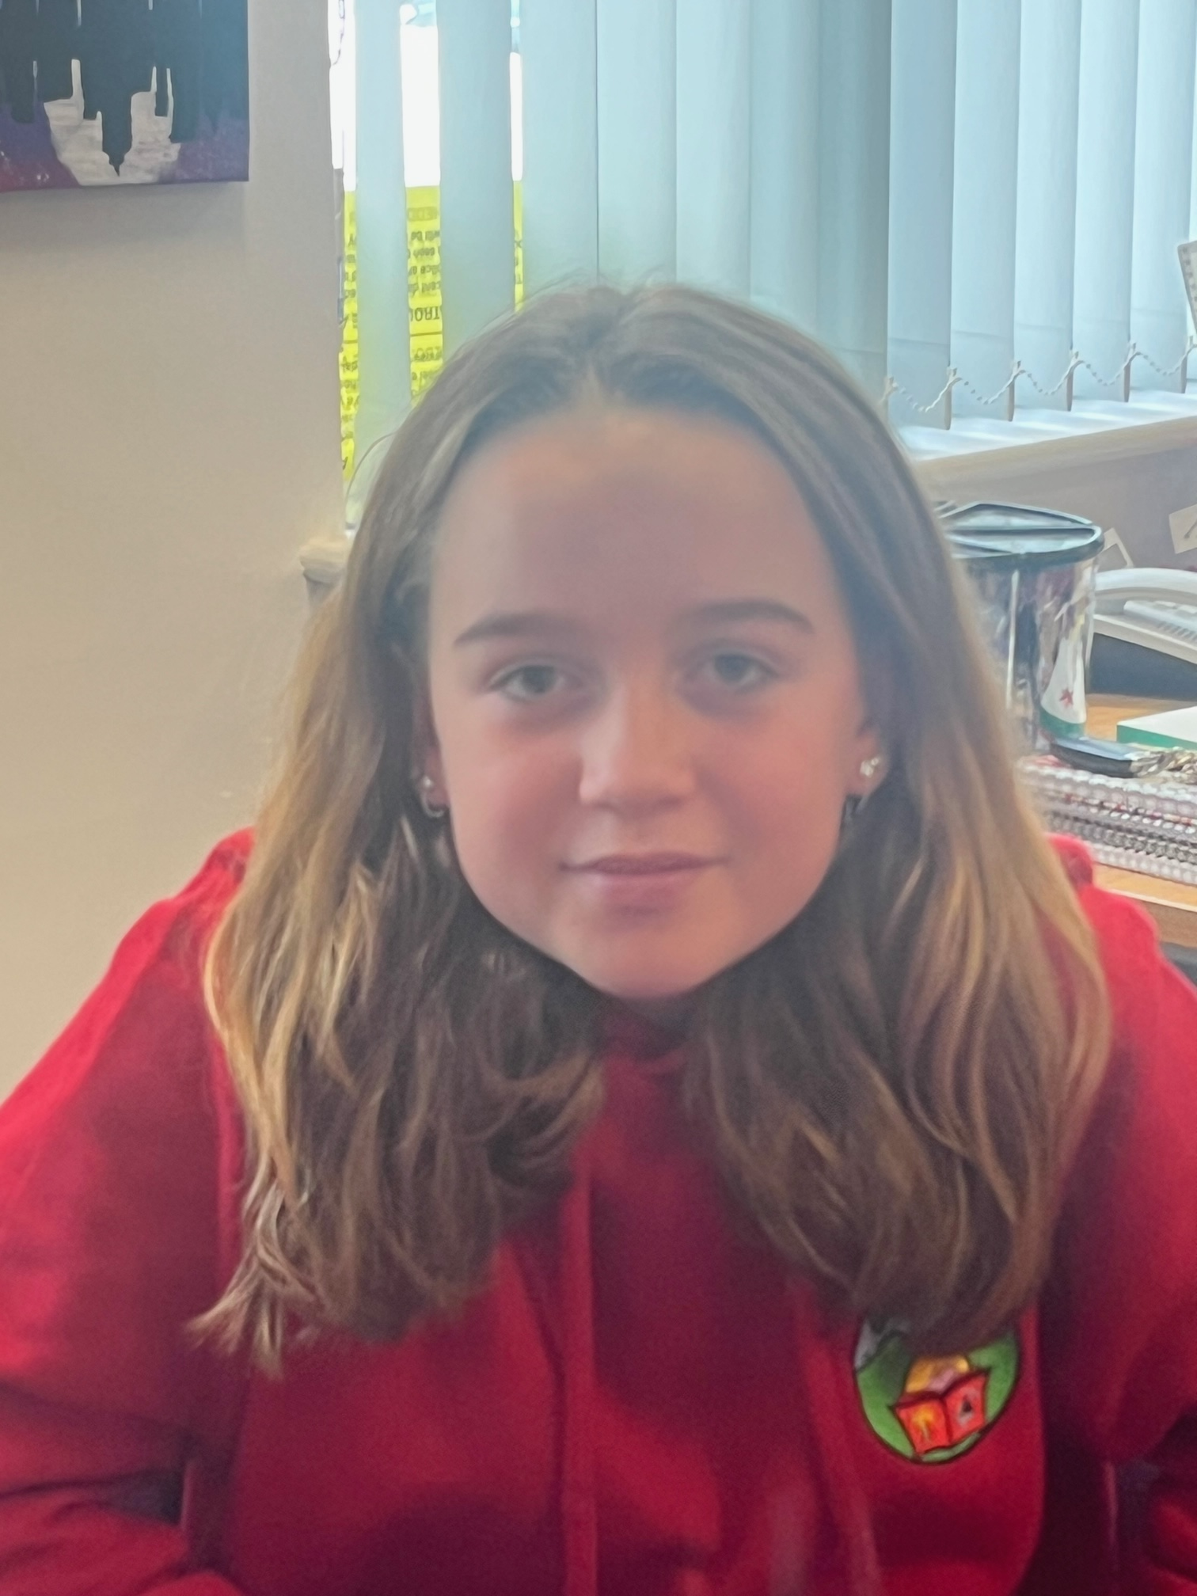
Lucas Dorgan Isaac
I like being on the school council – I am really to keen to help out around the school and make it a better place.
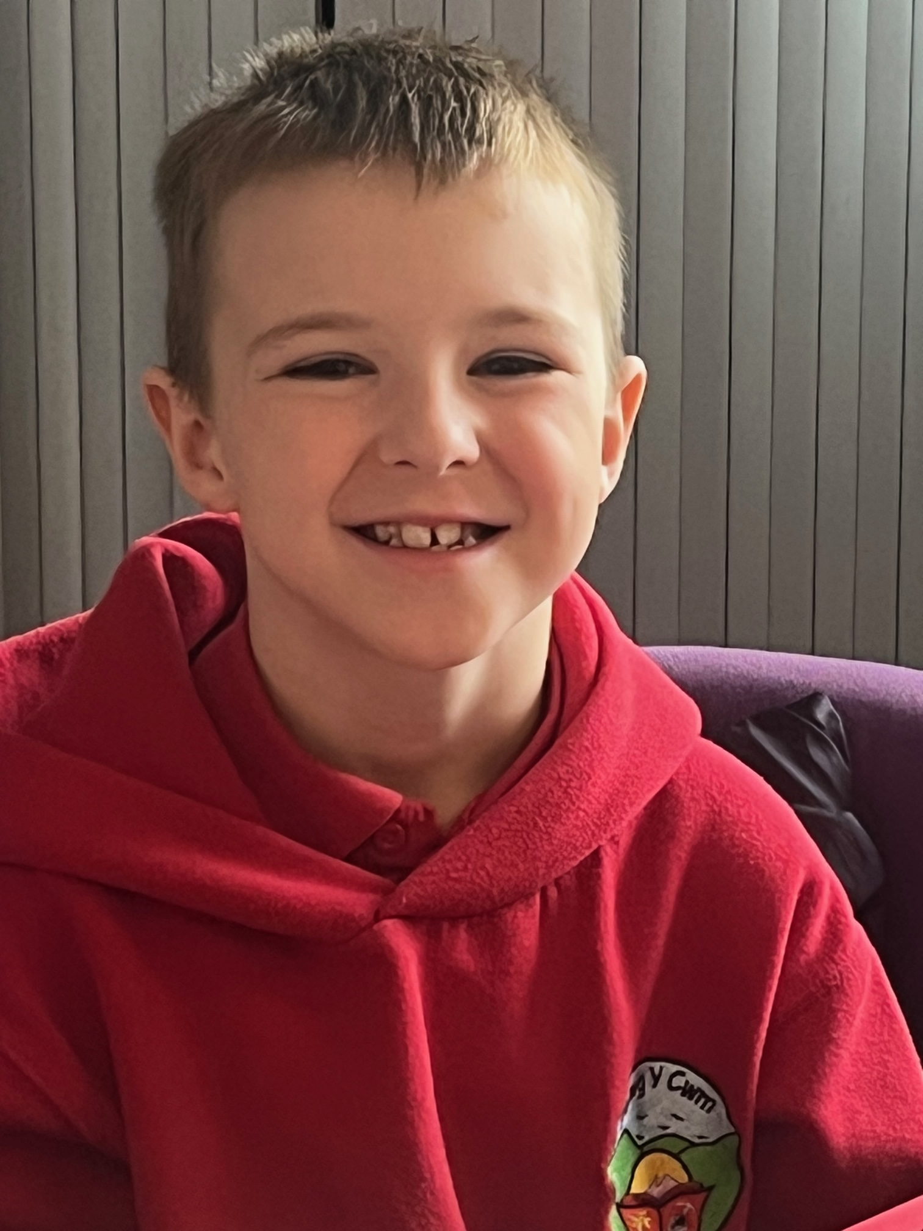
Tegan Evans Whittaker
I know that I can make a difference both in my class and outside on the school yard.
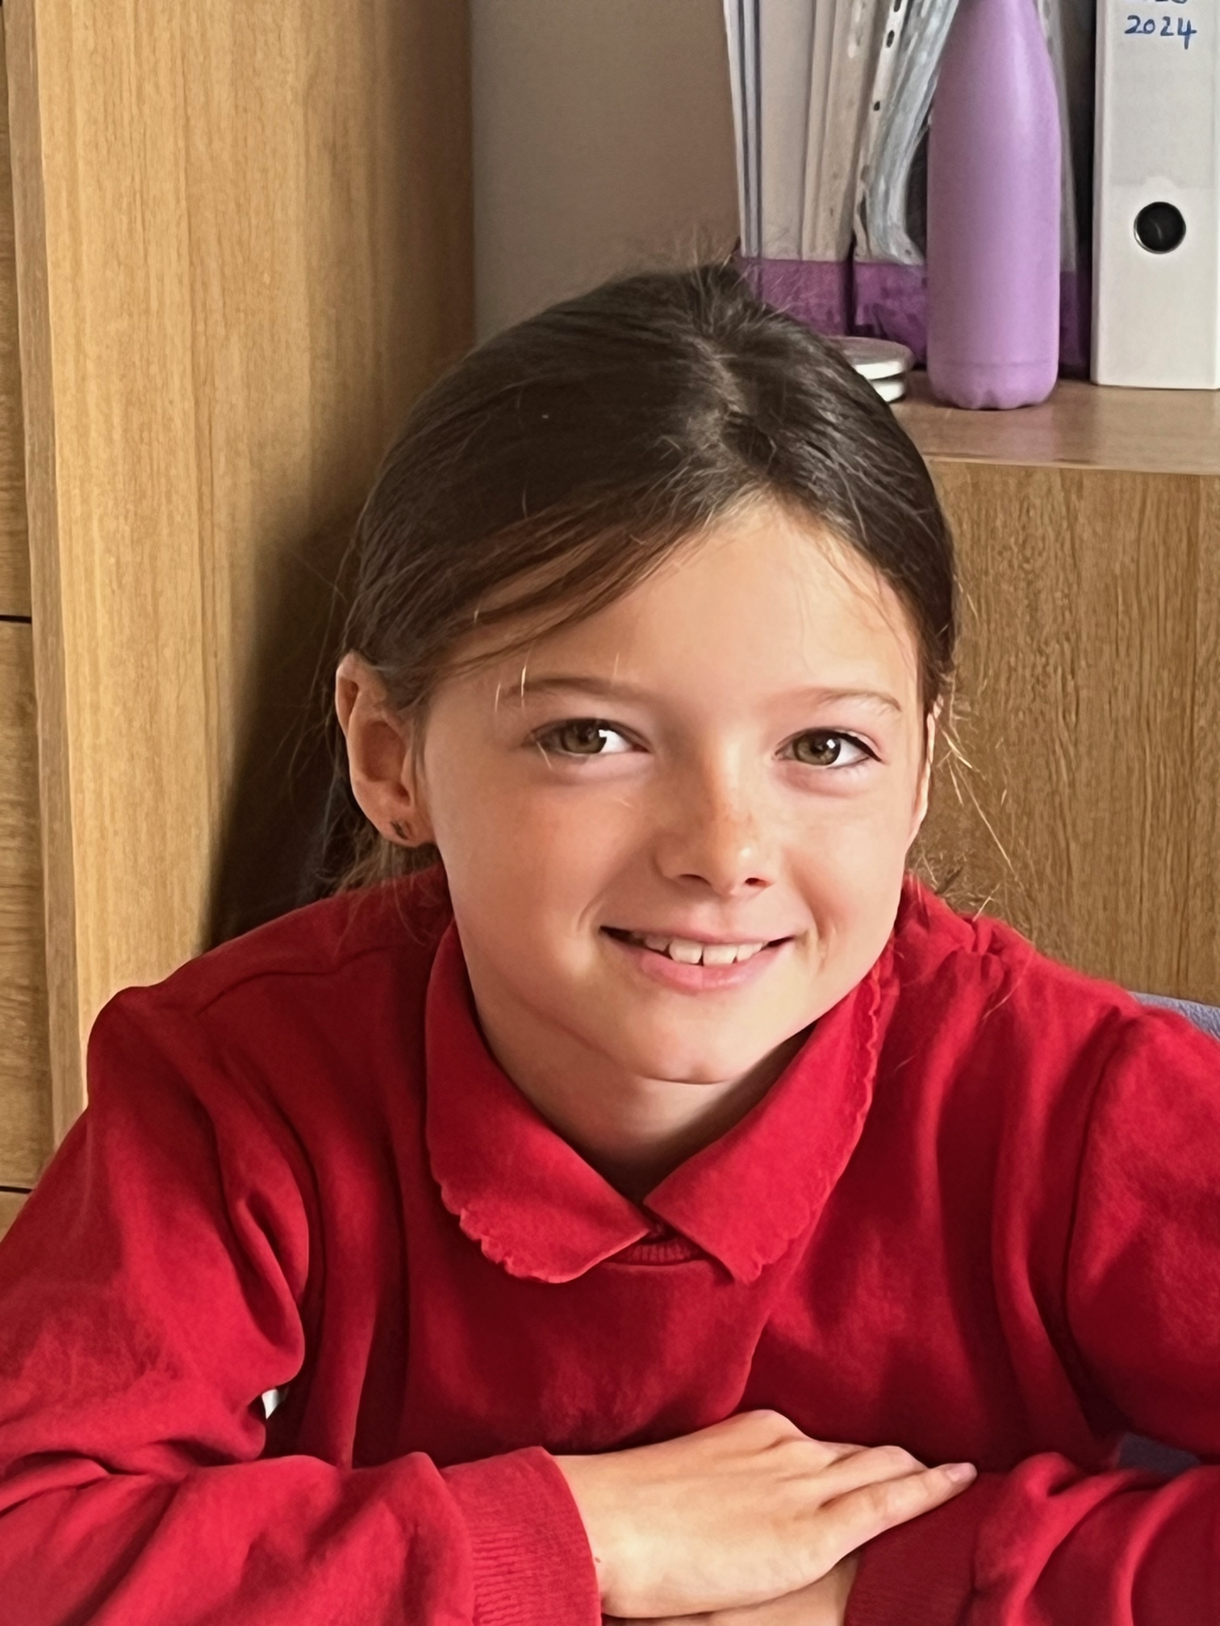
Zac Morgan
The school council I feel is important as I am willing and able to try and make a difference to my school. I can help anyone if they need it.
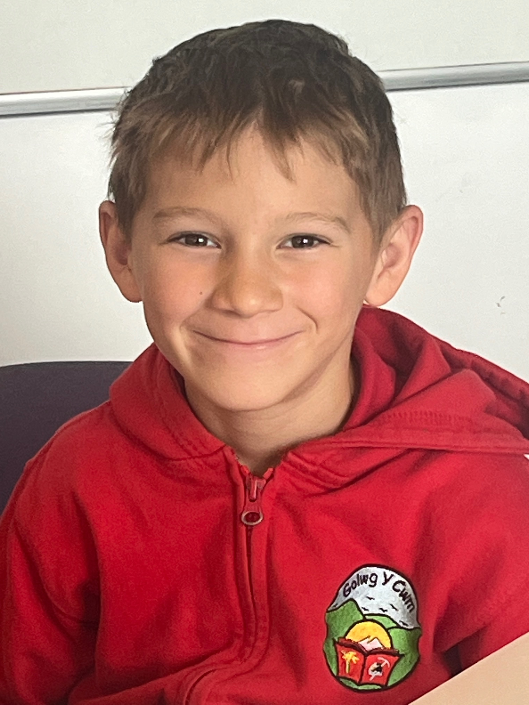

THE SCHOOL COUNCIL
2023 – 2024

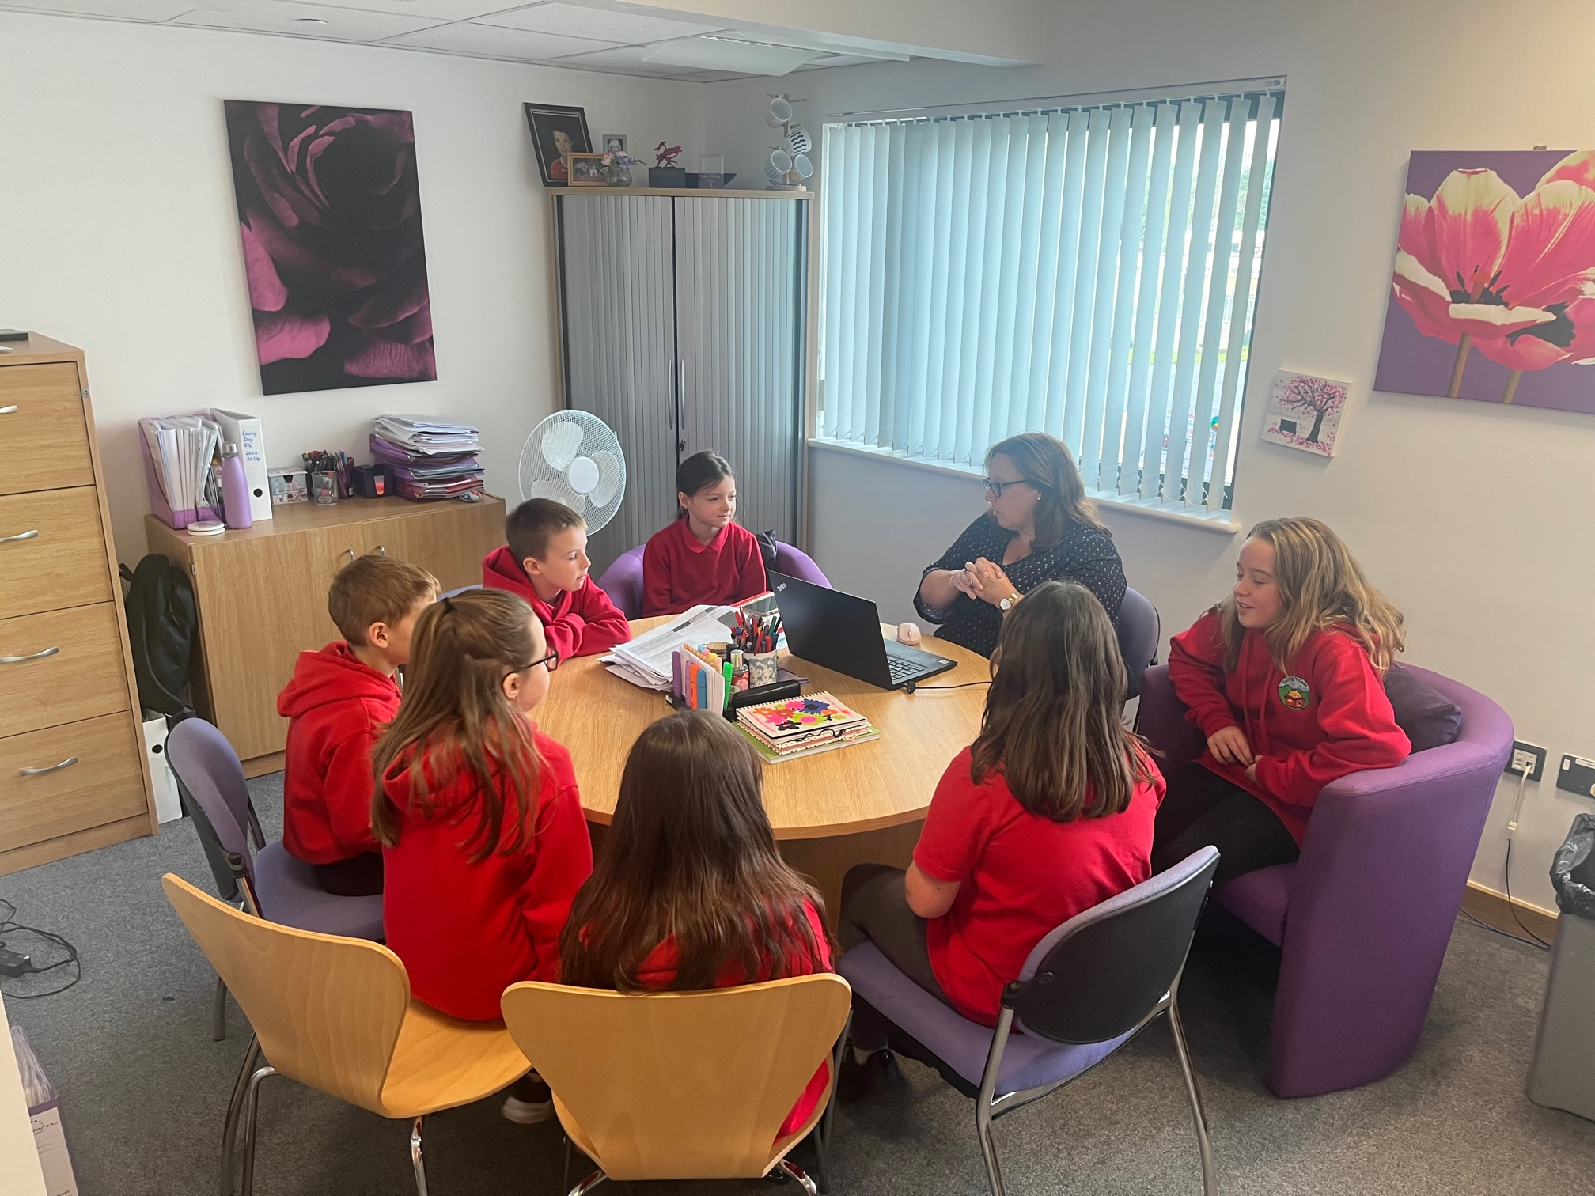

First meeting of the academic year….
Busy times ahead!!

