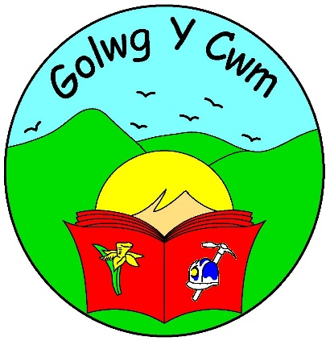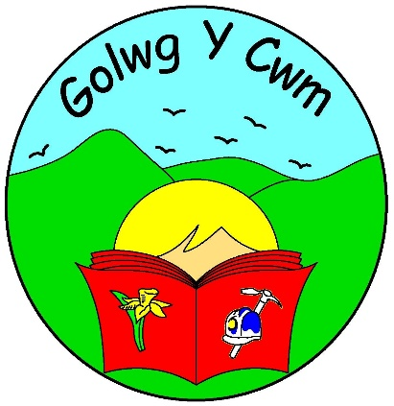 Child Protection

These are the people who will help.

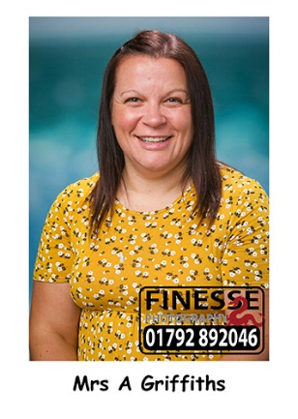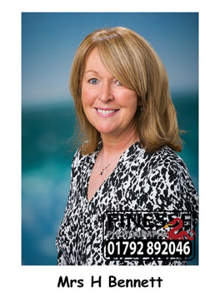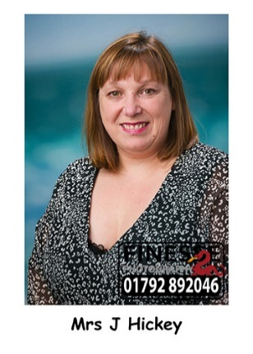

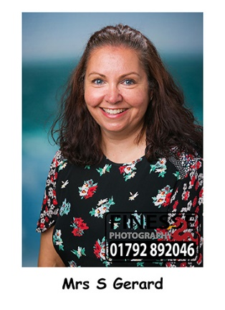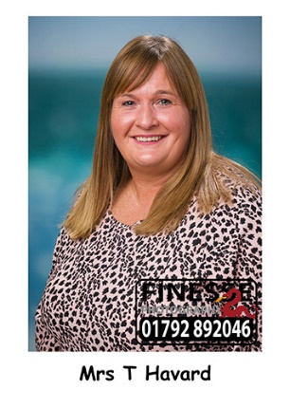

**Mrs Hickey**

**Mrs Griffiths**

**Mrs Bennett**

**Mrs Havard**

**Mrs Gerard**

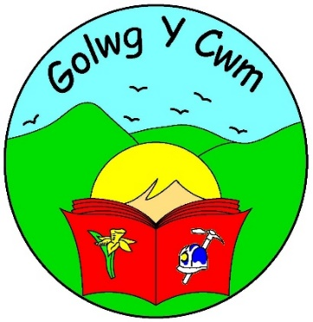Child Protection

Any child protection issues or concerns should be reported to the Child Protection Officer.

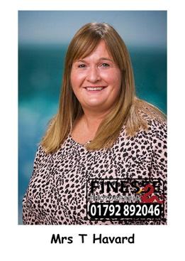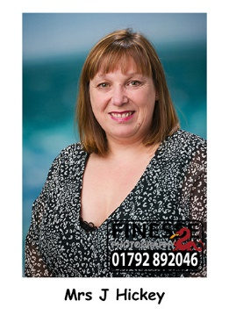

This schools Child Protection Officer is: -

Judith Hickey – Designated Safeguarding Lead (DSL)

(Head Teacher)

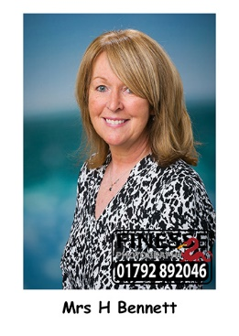If not available, then please speak to: -

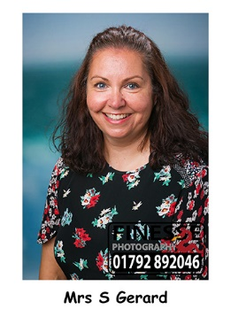Tracey Havard – Deputy Designated Lead (Deputy Headteacher)

If neither is available than you should speak to either of the Senior Management Team:-

Hayley Bennett or Sarah Gerard

The Governor responsible for Child Protection at Ysgol Golwg y Cwm

Allison Griffiths

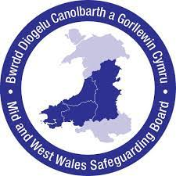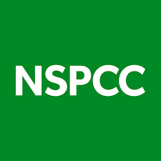DSL Contact Details: [head@golwgycwm.powys.sch.uk](mailto:head@golwgycwm.powys.sch.uk) / Tel: 01639846070